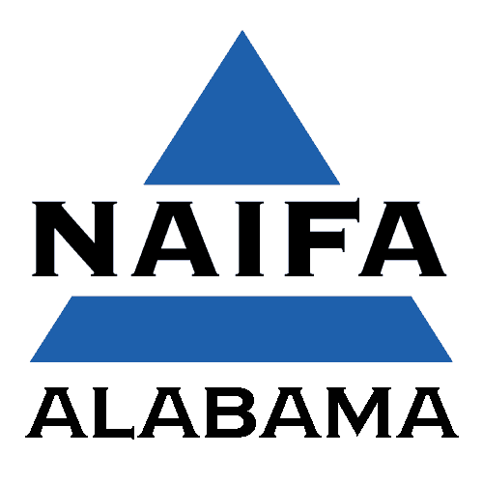
2020 Top Advisor
Application Submission Deadline:
October 1, 2020
NAIFA ALABAMA
P.O. Box 43067
Birmingham, Alabama 35243
allison@naifa-alabama.com

Name & Designation(s): |  |  |  | Date of Birth:
Name & Address of Company:
City: |  | State: |  |  | Zip:
Phone: | E-mail:
Years in Business: |  |  | 2018 Commissions ($75,000 minimum):
Area(s) of Specialization:
Currently an IFAPAC Contributor (circle): Yes No |  |  | Years in NAIFA :
Other Professional Organizations to Which You Belong:

----------------------------------------------------------------------------------------------------------------------------------------------------------------------
----------------------------------------------------------------------------------------------------------------------------------------------------------------------
----------------------------------------------------------------------------------------------------------------------------------------------------------------------
----------------------------------------------------------------------------------------------------------------------------------------------------------------------
----------------------------------------------------------------------------------------------------------------------———–———---————----
Community Involvement:

----------------------------------------------------------------------------------------------------------------------------------------------------------------------
----------------------------------------------------------------------------------------------------------------------------------------------------------------------
----------------------------------------------------------------------------------------------------------------------------------------------------------------------
----------------------------------------------------------------------------------------------------------------------------------------------------------------------
----------------------------------------------------------------------------——--------------------------------------------—————————--
Internal Use: Membership in NAIFA since
IFAPAC contribution confirmed __________

Top Advisor Agreement

Applicant Please Read and Sign Below:

By signing this agreement, I am indicating that the information reported in this awards application, specifically the commission amount, is both truthful and accurate. I also understand that NAIFA-ALABAMA may request records to verify any and all information at any point during the application process. Furthermore, I understand that if I am selected as a Top Advisor of NAIFA-ALABAMA, I am expected to maintain my membership for the ensuing year, and if I allow my membership to lapse, will be responsible for a pro-rated portion of the cost of the ad published that identifies me as an active member and Top Advisor of NAIFA-ALABAMA.

Applicant’s Signature Date

Applicant’s Printed Name

Agency Manager, Accountant or Bookkeeper, Please Read and Sign Below:

By signing this agreement, I am indicating that the information reported in this awards application, specifically the commission amount, is, to the best of my knowledge, both truthful and accurate. I also understand that NAIFA-ALABAMA may request records to verify any and all information at any point during the application process.

Signature Date

Printed Name

Please Return Your Completed Application and Supporting Material to:

NAIFA ALABAMA
P.O. Box 43067
Birmingham, Alabama 35243

Scan and Email: allison@naifa-alabama.com

Online Form – Visit www.naifa-alabama.com

Top Advisor 2020 Recognition Program

The Leadership of NAIFA-Alabama would like to recognize and promote active members of NAIFA that have demonstrated a commitment to excellence.
The Top Advisors program provides financial professionals at any career stage the opportunity to apply or be nominated for the following:
- Professionalism through education and earned designations
- Production measured by performance metrics customized for each practice specialty
- Adherence to the NAIFA code of ethics, and
- Service to your industry association
Advisors specializing in Life & Annuities, Financial Advising & Investments, Health & Employee Benefits, Multiline Sales or any combination of these specialties can demonstrate the quality that is the mark of a true professional. But they must be active NAIFA members.
You or a professional you know is a candidate. He or she is successful, of course, but also committed to their community, family and team. They’re already a great example for their peers. Nominate them for NAIFA-Alabama Top Advisor. It’s the recognition they deserve and the next step in their amazing career.
Recipients will appear in a local and state publication as well as promoted through social media.
Use the following application for nomination.

